Saxon Shore U3A Committee
Chair
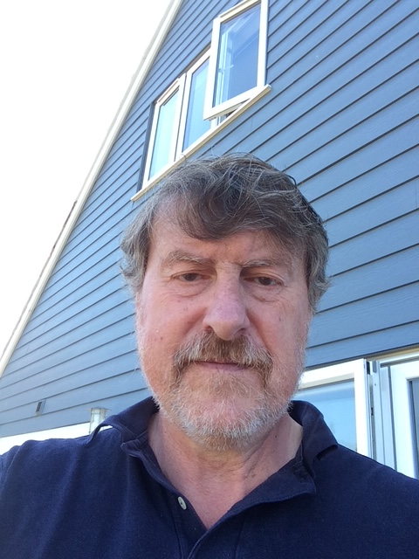 | David Cheetham - Originally from the Derbyshire coalfields and then lived in London for 18 years. I have lived in Whitstable now for 14 years, have 4 grown up offspring and 4 grandchildren. I have worked as an RAF pilot, adult education organiser, IT Manager, and when in business was Operations Director running a large IT networking consortium. I then worked at both Canterbury Christ Church and Kent Universities as a network planner. I now enjoy u3a, keeping fit, history, traditional Celtic music and walking.  I first joined u3a to do Tai Chi and now am a member of the Computer Group. I have found our u3a very friendly and enquiring and now want to grow Saxon Shore, promote new learning opportunities and perhaps collaborate more with neighbouring u3a branches to attract major speakers and events.  I have significant management, IT and organisational experience which I hope to bring to bear to lead and support the Committee.
Secretary
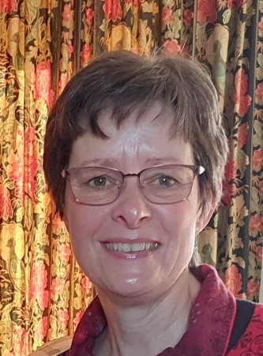 | Kim Todd - I moved to Whitstable in 2016 following my husband’s retirement from the Army. In 2017, we joined Saxon Shore u3a at its inaugural meeting at Swalecliffe Hall—mostly out of curiosity, and perhaps a little bravery, but mostly to make new friends. Since then, I have become a member of several groups that are not only social and educational, but—better still—great fun. I joined the Committee in 2023 and, before I quite knew what had happened, found myself taking on the role of Business Secretary in 2024.
Membership Secretary
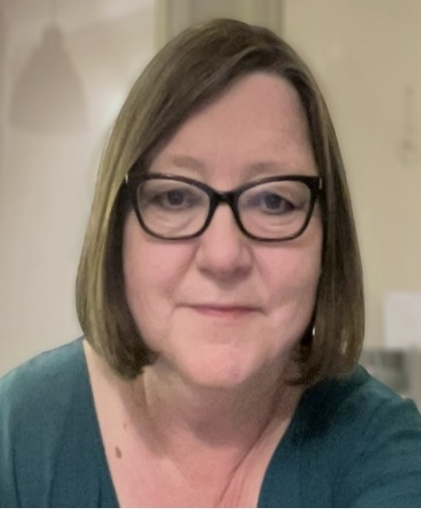 | Vikki Thompson - A Londoner who moved to Kent in the 1990’s, I have been a Samaritan (also taking on the role of outreach for my branch), charity shop worker (and manager), assistant manager at the Demelza warehouse and a trustee for The Children’s Fund (Medway). I have held various other voluntary positions since stepping back from our family printing business and currently run two online writing groups (my hobby is creative writing). I was Membership Secretary for Hawkhurst u3a until moving to Reculver in 2025. I feel very passionately about volunteering (it's in my blood) and giving back to the community. Membership Secretary is the ideal role for me as I love meeting new people.
Groups Coordinator
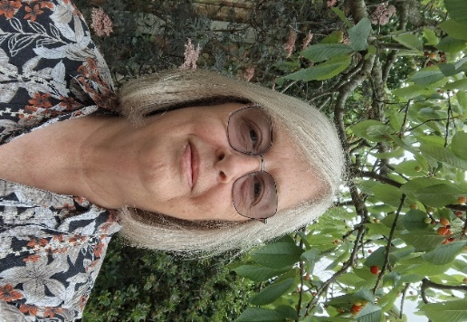 | Karen Cockbill - I have lived in the Herne Bay area since  1979. I joined Saxon Shore u3a in 2019 after I retired from a Dutiful and Taxing career in the civil service. I have a keen interest in creative pursuits as well as reading so have joined a few interest groups that cater for my need to make things. All groups have been welcoming and I have enjoyed the good-natured banter that keeps me going back to them. Since joining the Committee in 2025 I have taken on the role of Groups Coordinator. Helping groups of people who may never met before become a part of a new interest group has allowed me to become even more involved with our u3a.
Beacon Administrator
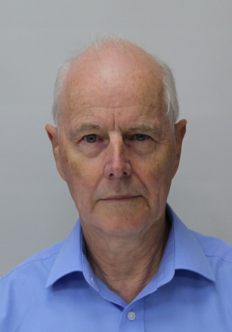 | John Edwards – I have lived in Whitstable most of my life, working all over Kent until early retirement. I have enjoyed being involved with many local organisations and charities during that time and was happy to offer to take on the role of Membership Secretary when our u3a was formed. I also act as Administrator of the Beacon Database system that keeps track of all our membership records and also facilitate the Computer group.
Speakers Organiser
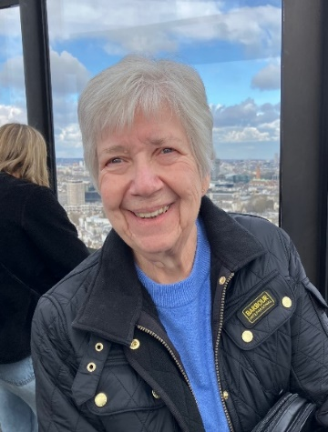 | Wendy Powell - I have lived in Tankerton for over 20 years and joined our Saxon Shore u3a when it was first launched. A family history group was suggested and being very interested I met with the Group leader and we agreed to get things going together. We haven’t looked back but still have an interested group who meet regularly. I have joined other groups too which is what makes u3a so special, members helping members. I am also an active member of a local WI and served on their committee for some time including seeking out Speakers for our meetings, something I feel may assist me in my new role with this committee.
Outings Organiser
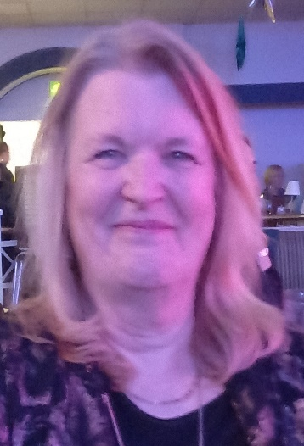 | Helga Cullum - I have lived in Kent since 2006 originating from the northeast of England. I joined Saxon Shore u3a when I began to live in Herne Bay. Before that I lived in Maidstone and attended King Hill u3a. I retired approximately 5 years ago after spending many years working with vulnerable children and families. Following retirement, I decided to volunteer with Citizens Advice as an Advisor for 3 years. I am a member of a few groups with Saxon Shore u3a and believe that u3a is a superb organisation especially for older people to allow them to socialize and learn new skills. I enjoy meeting people, and I am proud to be able to aid the development of Saxon Shore u3a as much as I can.
Outings Support
 | Colin Hartley - I spent my later childhood growing up in the south of Kent. I have been married for 45 years with two children (well I wouldn’t call them children anymore) and one granddaughter. Before retirement, my vocation in life was what you could jokingly say was a white-collar worker. If you think you’ve guessed what it is, then have a chat with me when you see me at the monthly meeting. I believe experience in my profession puts me in a good position to serve on the Saxon Shore u3a committee. My interest is music and I’m a member of both u3a Ukulele and Totally Folked Up groups, and I also play in a folk/country band called Rucosu.
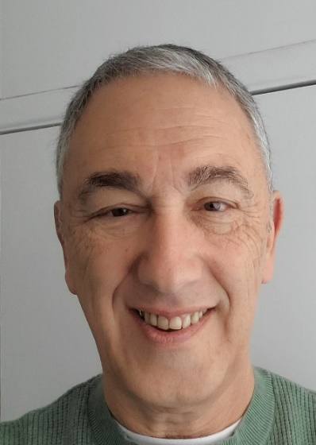 | Ray Cohen - I've lived in Whitstable for 35 years now. I worked for large life assurance and pensions companies, mostly finding out requirements for, and then designing, business and system processes and databases. I'm now retired and spend a lot of time writing. I've published a book of poems about business analysis and data (very niche!) and am now (Nov 2025) putting the finishing touches to a novel that I have been working on for almost 2 years. It’s about love and infatuation. I recently joined a u3a writing group and the short, sharp writing we do is an enjoyable relief from a novel. I hope to put my mix of business, system and data skills to good use for the continued success of the Saxon Shore u3a.

April 2026

